Judo Canada Regional Training Center
LETHBRIDGE

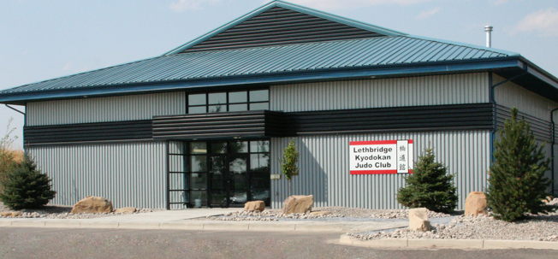

Judo Canada Regional Training Center Lethbridge Application
Please send all signed documents email to:
(e.beaton.judo@gmail.com)
Personal Information
Given Name ____________________________ Surname _____________________________
Date of Birth_________________ Sex_______________________
Current Address _________________________________________________________________
Phone Number__________________________ Email_________________________________
Age Group: U16 / U18 / U21 / Senior (circle one) Weight Class: _________________
Judo Canada Passport Number: ________________
Provincial Health Insurance Number: ______________
Education and Employment
Full-time Student (Name of School and Program, if applicable:
____________________________________________________________________)
Part-time Student (Name of School and Program, if applicable:
____________________________________________________________________)
Employed (Please state profession and employer: ________________________________)

Judo Canada Regional Training Center Lethbridge Application
List of Results
Best Results of Current Year
____________________________________________________________________________
____________________________________________________________________________
____________________________________________________________________________
Overall Career Best Results
____________________________________________________________________________
____________________________________________________________________________
____________________________________________________________________________
Goals
Please state your short-term goals.
____________________________________________________________________________
____________________________________________________________________________
Please state your long-term goals.
____________________________________________________________________________
____________________________________________________________________________
Personal Coach and Club Contact Information
Club _________________________________________________________________________
Adress_____________________________________________________________________
Coach:_____________________________________________________________________
Phone Number _____________________________Email______________________
Judo Canada Regional Training Center Lethbridge Application
Emergency Contact Information
Name _______________________________________________________________________
Adress_______________________________________________________________________
Phone Number_____________________ Email________________________ Relation _______________
Authorities
A) Statement of Injury/Illness
Indicate all illnesses and injuries that have affected your training in the last 12 months along with the name and address of consulting physician. Chronic injuries with permanent effects must also be declared.
Injury/Illness Physician Address and Phone Number
1_____________________________________________________________________________
2_____________________________________________________________________________
B) Medical Disclosure
I hereby authorise all hospitals, physicians, and all other persons from whom I have received treatment or examination to disclose to the Centre or its representatives all information pertaining to my illnesses or injuries, medical history, consultations, prescriptions or treatments as well as providing copies of all my medical or hospital records. A copy of this authorisation is to be deemed as valid and legitimate as the original signed document.
Athlete Signature _____________________________ Date __________________
C) Likeness and Media Rights
I hereby authorise Judo Canada and its affiliated associations to use my likeness for the Judo Canada and its federations’ website, for social media and for judo-related publicity.
Athlete Signature _____________________________ Date _______________
Judo Canada Regional Training Center Lethbridge Application
D) Declaration and Signature
I wish to be considered for admission or readmission in the Regional Training Centre Lethbridge. I declare that all the information presented on this application form is exact and complete. I understand that the Regional Training Centre Lethbridge reserves the right to modify or reverse any decision on the subject of my admission if any of the above information is inexact or incomplete. This application will not be accepted if any element remains inexact or incomplete.
Athlete Signature _____________________________ Date __________________
For athletes under 18 years of age, the parent, tutor or guardian must sign as the legal guarantor:
Name (Please Print) ____________________Relation to Athlete __________________
Address ______________________________________ City _________________________
Province_________ Postal Code _______________ Phone Number___________________
Email ____________________________________________________________________
Signature ____________________________________ Date __________________________
Club Coach Signature ____________________ Date ___________

